Graph-based clustering of crime data based on relationship origins

Nithul K Anil¹, Madhumitha², Gulshan Kumar³, Raj Kishore Kumar⁴, Dr J Jagadeesan^{5*}

Department Of Computer Science and Engineering, Aarupadai Veedu Institute of Technology affiliated to A Constituent Vinayaka Mission’s Research Foundation, Chennai, Tamil Nādu, India.

*Corresponding authors mail id:

ABSTRACT:
Today, Information technology and mobile devices have permeated every aspect of our life. Since readily accessible information is never available during an investigation, which is a major communication barrier in the police department, this is a new area where mobile phones and technology have combined to be effective for reporting crimes. In order to speed up the process of finding the offenders, we will endeavor to make all the information linked to thieves, theft cases, and missing persons cases accessible to the police on the Android Application during their investigation The general public can also access a smartphone application to find criminals and potential thieves. Using this application, the user can file the case through their Mobile Application. This will make the communication bridge between the people and the police. The police will be able to remotely access criminal data with the aid of this programmer. Additionally, it will be helpful to store a lot of data, and it will offer a simple way to obtain information about how the crime was committed. For remote access, the data will be kept in the cloud. Because the crime rate has been rapidly increased so it is always safe to maintain a cloud server.

Keywords: Authentication, admin, police, Database, Criminal Activities, Smartphone Application, Potential Thieves

1.INTRODUCTION
The era of today is looking for a lot of potential in mobile technologies. Other industries and applications for this technology include gaming, maps, e-mail, messaging, photography, and many more. The identification and storage of criminal data records is one such field. In an effort to reduce crime, the Victoria Police Department in Canada has released smartphone Vic PD. The mobile app can be used to report minor crimes, give anonymous tips to the police, monitor ongoing investigations, receive reports of missing children, and locate stolen property. Because criminal data cannot be accessed remotely, there is a communication gap between the police officers investigating any case. The disadvantage of this programmer was that there was no other way to verify that the incident was real, which left it open to allegations of crimes that never happened. Therefore, the people grew confused. By offering a mechanism for validating the incidence, this paper focuses on resolving this drawback. This programmer will be helpful for the police department's investigations because it will allow remote access to criminal data. Additionally, it will offer regular users the ability to report any incidences that cause traffic congestion. Additionally, it will offer a different safe path upon request from the user before they enter the crime area. This project's database will be kept in the cloud so that it may be accessed from anywhere. The submitted information will first be verified by the police personnel in order to prevent any fraudulent incidents from being reported to other users. The information will be made available to other users of the application once it has been approved. The goal of this project is to create a programmer that can record and maintain crimes. This reporting tool can be used to record a crime or an accident at any time or location. to create a portable application that would act as a communication channel between users and law enforcement.

2.METHODOLOGY
2.1 MODULE
Software is organized into modules, which are individually identified and addressable parts that can be combined to meet the needs of a problem. The only characteristic of software that makes a programmer manageable on an intellectual level is modularity.
There are 4 modules:
- Authentication Module
- Admin Module
- Police Module
- User Module
2.1.1. AUTHENTICATION MODULE
In this module, all the three participants should get Authentication to the application. The Server then validates the Login procedure. If the login is successful, then they get authentication to use the application. Separate Login for Admin, User and Police has been provided.

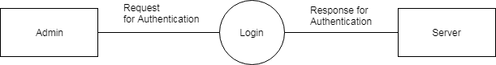
Figure 2.1. a) Login Verification

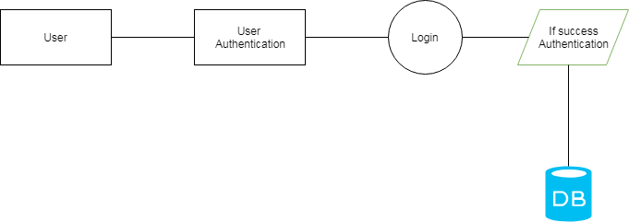
Figure 2.1. b) Success Authentication

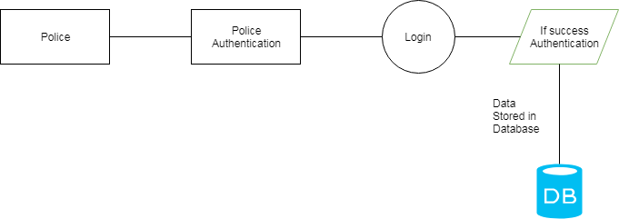
Figure 2.1.c) Separate login
2.1.2. ADMIN MODULE
In this module, the admin manages the details of user and the police. They can manage their details as well as provide service to them. After the validation process, the admin can do this. Once the admin logins to the application they can maintain the details of the police as well as the public

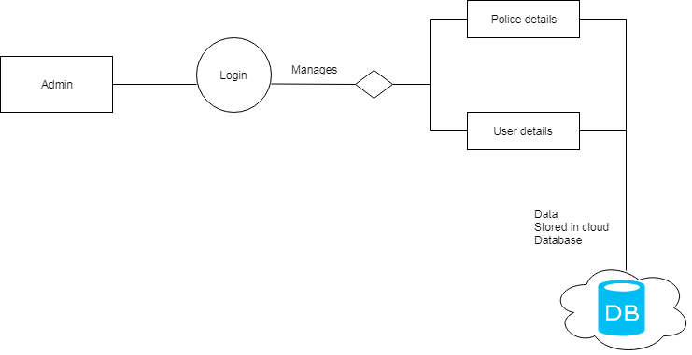
Figure 2.1.2. Validation Process
2.1.3. POLICE MODULE
- This module mainly concentrates on the police. When the police get login, they can have the option to enter the details of criminals and crime details.
- They can also read the complaints filed by the public. They separate the crime by the area and store the details in the cloud server.
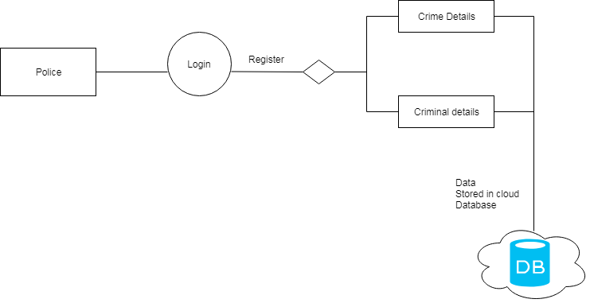
Figure 2.1.3. Storage of the details in the cloud Server
2.1.4. USER MODULE
- This module mainly concentrates on the public. When the public gets login, they can have the option to enter the details of the missing case.
- They can also view the crime and criminal information nearby them
- They can also can rate the police in their area, since they cannot go to the station directly also they cannot file a case against police.

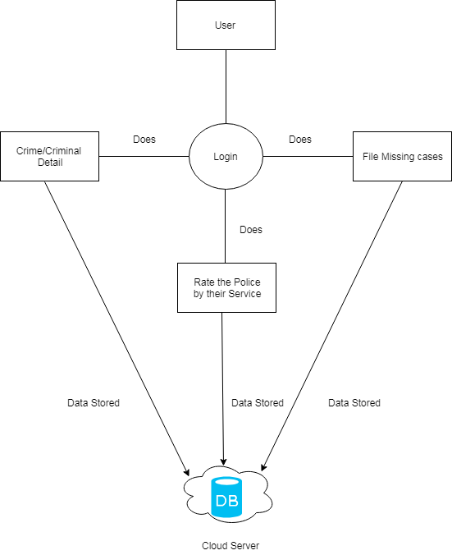
Figure 2.1.4 : Rating the police by the cloud server

Architecture diagramming is the process of developing visual representations of application components. The principles, elements, and components of a set of concepts that make up the architecture are represented graphically in an architecture diagram. Architecture of an application relates to distinct functionalities, their implementations, and how they interact with one another. Architecture diagrams physically depict the numerous data movements within the application because software is by nature abstract. They also emphasise how the application engages with its surroundings.

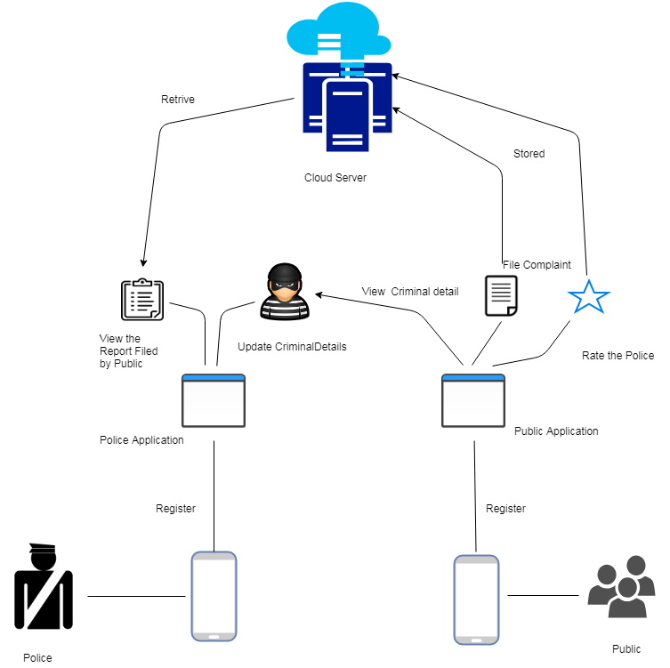
Figure 1: Creating visual representations of application components.
The goal of the system analysis is to create a quick analysis work as well as to establish comprehensive knowledge of the concept, behavior, and other restrictions like performance metrics and system optimization. System analysis is to concisely and unambiguously define the technological specifics pertaining to the fundamental notion.
3.RESULT AND DISCUSSION

3.1 EXISTING SYSTEM
- In Existing, we conduct cluster analysis on an Indian crime dataset. A unique India m is made using the cluster input.
- a map showing the states' cluster zones.
- The customized maps show a state's overall crime profile, assisting police and law enforcement agencies in developing more comprehensive investigation plans and additional preventative measures to combat crime. These details are visible to police officials. Also, people can only know only the crime zone and not the criminals.
- They can't file cases against the crime.
- The Storage Maintenance plays a tough role in this system.
3.1.1. DISADVANTAGES
- There is information about the criminals.
- Zoning and mapping are difficult to handle.
- Less interaction between police and the public.
- Criminal Activities Cannot be Filed online.
3.2. PROPOSED SYSTEM
- The objective of this post is to build an Android application for storing criminal records and identifying crime hotspots. It offers the user access to an application that would disclose information about the criminals.
- Users can report incidents, thefts, and missing persons and have them checked by police officers.
- It will include a police department application that can perform database operations on criminal records and quickly retrieve the data that is needed from a centralized database that is located in the cloud.
- The programmer is designed to help the general public and police officers manage crises and crimes quickly. Fine interaction between people and the police is maintained.
- The user can also rate police officers.
3.2.1. ADVANTAGES
- Information about the criminal can be viewed by the police as well as the public.
- More interaction between the police and the public.
- Criminal activities can be filed online.
- Low Risk of Data Loss since the data gets stored in the Cloud.
- Cases can be shared between the officials easily.
- CONCLUSION
The issue of poor communication amongst resolved by the police throughout their inquiry. Additionally, police officials will have simple access to criminal information because it is saved on the cloud. Because this programmer demands police verification before publishing incidents that users report to other users of the same application, the problem of reporting phone crimes will be resolved. Users will be able to file complaints straight from their homes with the aid of this initiative. Other security algorithms might be implemented in the future to offer the criminal database better security protections.
REFERENCES
[1] William Akotam Agangiba,Millicent Akotam Agangiba, Mobile solution for Metropolitan Crime Detection and Reporting, Journal of Emerging Trends in Computing and Information sciences, Vol.4, No. 12, 2013, 2079-8407.
[2] VicPD, Report Crime, Tack Crime, Fight Crime, From your pocket, available at: https://www.vicpd.ca/mobile [Accessed: 29/10/2013].M.
[3] Manav Singhal, Anupam Shukla,”Implementation of location based services in Android using GPS and Web Services”,(IJCSI) International Journal of Computer Science Issues, Vol. 9, Issue 1, No. 2, January 2012, 1694-0814.
[4] Mayur Dhande, Amruta Barawkar, Raman Dhoot,”Android Bachaosos Application”, (IJCTA) International Journal of Computer Technology and Application, Vol. 5 (3), 826-828.
[5] Pragya Gupta, Sudha Gupta,”Mobile Cloud Computing: The Future of Cloud”, International Journal of Advanced Research in Electrical, Electronics and Instrumentation Engineering, Vol. 1, Issue 3, September 2012.
[6] Surbhi Aggarwal, Neha Goyal, Kirti Aggarwal, “A review of comparative study of MD5 and SHA security Algorithm”, International Journals of Computer Application (0975-8887), Vol. 104-No. 14October-2014
[7] R. F. Benjamin Rosenfeld, “Ures : an unsupervised web relation extraction system,” in Proceedings of the 21st International Conference on Com- putational Linguistics and 44th Annual Meeting of the Association for Computational Linguistics, 2006, pp. 667–674.
[8] Z. Syed and E. Viegas, “A hybrid approach to unsupervised relation dis- cover based on linguistic analysis and semantic typing,” in Proceedings of the NAACL HLT 2010 First International Workshop on Formalisms and Methodology for Learning by Reading, 2010, pp. 105–113.

[9] T. P. Mohamed, E. R. Hruschka, Jr., and T. M. Mitchell, “Discovering relations between noun categories,” in Proceedings of the Conference on Empirical Methods in Natural Language Processing, Association for Computational Linguistics, set. EMNLP ’11, 2011, pp. 1447–1455.

[10] A. Akbik, L. Visengeriyeva, P. Herger, H. Hemsen, A. Löser et al., “Un- supervised discovery of relations and discriminatory extraction patterns.” Citeseer, 2012.

[11] W. Wang, R. Besançon, O. Ferret, and B. Grau, “Filtering and clustering relations for unsupervised information extraction in open domain,” in Proceedings of the 20th ACM International Conference on Information and Knowledge Management, 2011, pp. 1405–1414.
[12] I. Boujelben, S. Jamoussi, and A. Ben Hamadou, RelANE: Discovering Relations between Arabic Named Entities. Springer International Pub- lishing, 2014, pp. 233–239.

- R. Basili, C. Giannone, C. Del Vescovo, A. Moschitti, and P. Naggar, “Kernel-based relation extraction for crime investigation,” in AI*IA. Cite- seer, 2009, pp. 161–171.

[14] R. Arulanandam, B. T. R. Savarimuthu, and M. A. Purvis, “Extracting crime information from online newspaper articles,” in Second Australasian Web Conference (AWC 2014), vol. 155, Jan 2014, pp. 31–38.

[15] H. A. Shabat and N. Omar, “Named entity recognition in crime news doc- events using classifiers combination,” Middle-East Journal of Scientific Research, vol. 23, no. 6, pp. 1215–1221, 2015.

